**Review Worksheet ANSWERS: Neurons**

*.*

1: Label the diagram to identify the axon, cell body, myelin sheath, dendrite, nucleus, axon terminal, cytoplasm, node of Ranvier, and Schwann cell.

(4.5 marks)

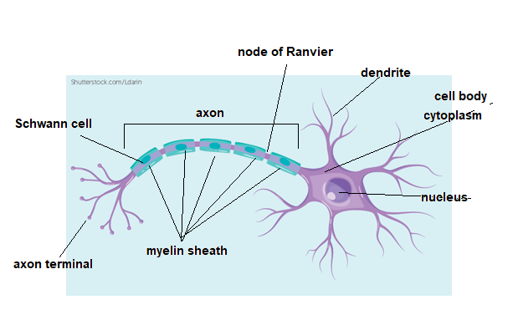

2: Complete the table to state the function of each part of the neuron

(2.5 marks)

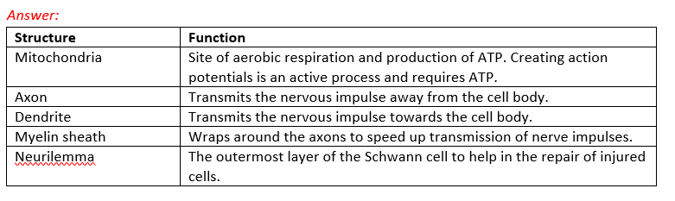

3: State the function of:

(3 marks)

Motor Neurons – *carry impulses from the CNS towards the body to respond / to the effector*

Interneurons – *link motor and sensory neurons in the CNS*

Sensory Neurons – *carry sensory information from receptors in the body to the CNS*

4: What structural type are sensory neurons?

(1 mark)

*Sensory neurons are pseudounipolar*

5: What functional types of neurons are usually multipolar?

(1 mark)

*Interneurons (0.5) and motor neurons (0.5) are usually multipolar*

6: Where would interneurons be found?

(2 marks)

*Interneurons are found in the brain (0.5) and spinal cord (0.5) which make up the central nervous system (1)*

7: Classify the neuron shown below and justify your choice by describing the structural features that led you to your classification.

(3 marks)

*The neuron is a bipolar (1) neuron. It has one axon (0.5) and one dendrite (0.5), both of which branch at the ends (1)*

8: Are nerves and neurons the same thing? Explain your answer.

(4 marks)

*No (1). Neurons are single cells that carry impulses (1). Nerves are made of many bundles of neurons (1), held together by connective tissue (1)*

9: Mixed nerves are:

(1 mark)

A: Nerves where impulses travel both up and down each neuron

**B:** **Nerves that contain bundles of both sensory and motor fibres**

C: Nerves that contain only pseudounipolar neurons

D: Not found in humans

10: Define “synapse” and state the function of the synapse.

(6 marks)

*The synapse is the junction (1) where the axon of one neuron meets the dendrite of another (1) and the nerve impulse is passed across (1). The axon and dendrite do not touch. There is a gap between them (1). The axon releases neurotransmitters (1) which cross the gap and stimulate the dendrite. (1)*

11: Why is the white matter in the brain white in colour?

(2 marks)

*The white matter is white because it contains the axons of the neurons in the brain (1), which are coated in myelin (1), which is white in colour.*